1. INTRODUCTION

1.1 Domain Analysis and Requirements
“Computer Lab Database Management” deals with Computerization and maintenance of the lab. The lab administrator is expected to perform the tedious task of documentation, searching as well as updating. This creates the need for an organized storage of data to improve the service provided. It is also an effective method to visualize the status of the lab. The project would thus provide a user-friendly and robust package to cater to the requirements of the lab.

The databases of students, administrators, systems, passwords, time-table and the history are to be maintained in the lab.

- The student database contains the details of the students such as his name, register number, semester, batch number, etc.

- The system database contains the system number, the status (working/not working, allocated, free) and the system configuration details.

- The administrator’s database contains his name, id and password.

- The password database contains student’s password, login times and his/her register number.

- The time-table database contains the time-table schedule associated with a particular lab and their in charges.

- The student can reserve the system to work in free hours.

The history database stores the usage of the particular system by a particular student.

2. SYSTEM DESIGN

2.1 DATA FLOW DIAGRAM

What is the use of Data Flow Diagram?

Data flow diagrams are useful and intuitive way of describing the system. They are normally understandable without special training, especially if control information is excluded. They show end to end processing i.e. the flow of processing from when data enters the system to where it leaves the system can be traced.
The symbols used to represent the data flow diagram entities are shown below :

- Circles represent functions, which transforms inputs to outputs.
- Rectangle represent the entity in consideration
- Single lines represent data stores.
- Arrows show the direction of data flow.

Notation Meaning

Entity

Process

Data Flow

Data Store

2.2 ENTITY-RELATIONSHIP DIAGRAM

The schema for a database application can be displayed by means of the graphical notation known as ER diagrams.
The Entity-Relationship (ER) model is a popular high level conceptual data model. This model and its variation are frequently used for conceptual design of applications and many tools employ its concepts.
It is based on the perception of real world, which consists of a set of basic objects called entities and relationships. In the diagram model, the data depicts how the business views its structure. An entity is a “thing” in the real world with an independent existence. Each entity has an attribute and an associated value for each attribute.

The notations used and their meanings are given below

Notations Meaning

Entity

Weak Entity

Relationship

Attribute

Key Attribute

Multi valued

…
` Composite Attribute

3. DETAILED DESIGN

ER to Relational Mapping focuses on designing a relational database schema based on a conceptual schema design. The algorithm that can map an ER schema into the corresponding relational database schema is as follows:

STEP 1: For each regular strong entity type E in the ER scheme, create a relation R that includes all the attributes of a composite attribute. Choose one of the key attributes of E as a primary key of R. If the chosen key of E is composite, the set of simple attributes that form it will together form the primary key of R.

STEP 2: For each weak entity type W in the ER schema with owner entity type E, create a relation R and include all simple attributes (or simple components of composite attributes) of W as attribute of R. In addition, include as foreign key attributes of R the primary key attribute(s) of the relation(s) that correspond to the owner entity type(s); this takes care of the identifying relation type of W. The primary key of R is the combination of the primary key(s) of the owner(s) and the partial key of the weak entity type W, if any.

STEP 3: For each binary 1:1 relationship type R in the ER schema, identify the relations S and T that correspond to the entity types participating in R. Choose one of the relation, say S, and include as foreign key in S the primary key of T. It is better to choose an entity type with total participation in R the role of S. Include all simple attributes (or simple components of composite attributes) of the 1:1 relation type R as attribute of S.

STEP 4: For each binary 1:1 relationship type R in the ER schema, identify the relation S that represents the participating entity type at the N-side of the relation type.
Include as foreign key the primary key of the relation T that represents the other entity type participating in R; this is because each entity instance on the N-side is related to at most one entity instance on the 1-side of the relation type. Include any simple (or simple components of composite attributes) of the 1: N relationship type as attributes of S.

STEP 5: For each binary M: N relation type R creates a new relation S to represent R.

Include as foreign key attributes in S, the primary keys of the relations that represent the participating entity types; their combination will form the primary key of S. Also include any simple attributes of the M: N relationship type (or simple components of composite attributes) as attributes of S. Notice that we cannot represent an M: N relationship type by a single foreign key attribute in one of the participating relations as we did for 1:1 or 1: N relationship types because of the M: N cardinality ratio.

STEP 6: For each multi-valued attribute A, create a new relation R. This relation R will include an attribute corresponding to A, plus the primary key attribute K, as a foreign key in R, of the relation that represents the entity type or relationship type that has A as an attribute. The primary key of R is the combination of A and K. If the multi-valued attribute is composite, we include its simple components.

STEP 7: For each n-ary relation type R, where n>2, create a new relation S to represent R. Include as foreign key attributes in S, the primary keys of the relation that represent the participating entity types. Also include any simple attributes of the n-ary relationship type as attributes of S. The primary key of S is usually a combination of all the foreign keys that reference the relations representing the participating entity types. If the cardinality constraints o any of the entity types E participating in R is 1, then the primary key of S should not include the foreign key attribute that references the relation E` corresponding to E.

This concludes the mapping procedure.

3.1 Description of Tables:
The tables present in the computer lab database management are as follows:
- LAB
- ADMINISTRATOR
- STUDENT
- PASSWORD
- SYSTEM
- RESERVATION
- HISTORY
- TIME_TABLE
The lab table consists of attributes such as lab name, department and number of systems. Here, lab name is the primary key and number of systems will have a default value of zero.
The administrator table consists of attributes such as name, id no, lab and password. Here, id no is the primary key and lab entry should not be null.
The student table consists of attributes such as name, register number, semester and department. Here register number is the primary key and name field should not be null.
The password table consists of attributes of student such as password, login times and register number. Here, registration number is the primary key, default value for password is student and default value for login times is zero.
The time_table table consists of attributes such as lab, batch, start time, end time, incharge and day of the week. Here lab references the lab name of the lab table and start time and end time are of type variable character type.
The reservation table consists of attributes such as lab name, time, register number of the student. Here, reservation table references the lab table for lab name, student table for register number.
The system table consists of attributes such as system number and details of the system such as mother board, floppy drive, cost, etc to name a few. Here system number is the primary key and the system name should not be null.

4. NORMALIZATION
Normalization is a process that takes the relational schema through series of tests to certify whether or not it belongs to a certain normal form. It also aims at refining the data structures to minimize data redundancy and to avoid update anomalies in the database.

4.1 First Normal Form (1NF)
First normal form (1NF) states that the domain of an attribute must include only atomic (simple, indivisible) values and that the value of any attribute in a tuple must be a single value from the domain of that attribute. Hence, 1NF disallows having a set of values, a tuple of values, or a combination of both as an attribute value for a single tuple.

USERS
ID | REG_NO | SEM | STUD NAME | ADMIN NAME | BATCH | PASSWD | LOGIN | BRANCH | LAB

LABSYS
LAB_NAME |  | DEPT |  | NO_OF_SYS
SYS_NO | LAB |  | PROCESSOR |  | MOTHER_BOARD |  | PR_MEM | SE_MEM
CDR_DRIVE | CDRW_DRIVE | MON_SIZE | MON_TYPE | KEY_BOARD | FL_DRIVE
MOUSE | INTERNET | PRINTER | VALUE | STATUS

PASSWORD
STUDENT_ID | LOGIN_TIMES | PASSWD

RESERVATION
USER_ID | NAME | SYS_NO | RES_TIME | RES_DATE

TIME_TABLE
DAY | START_TIME | END_TIME | LAB | BATCH | INCHARGE

HISTORY
USER_ID | NAME | LAB_NAME | SYS_NO | LOGIN | LOGOUT
Tables after 1NF

4.2 Second Normal Form (2NF)
Second normal from (2NF) is based on the concept of full functional dependency. A functional dependency X->Y is a fully functional dependency if removal of any attribute A from X means that the dependency does not hold any more.
A relation schema R is in 2NF if every nonprime attribute A in R is fully functionally dependent on the primary key of R.

USERS
ADMIN ID | REG_NO | SEM | STUD NAME | ADMIN NAME | BATCH | PASSWD | BRANCH | LAB
FD1

FD2

FD1 =>
STUDENT
NAME | REG_NO | SEM | BATCH | BRANCH

FD2 =>
ADMINISTRATOR
NAME | ID | LAB | PASSWD

Table after 2NF

4.3 Third Normal Form (3NF)
Third normal form (3NF) is based on the concept of transitive dependency. A functional dependency X->Y in a relation schema R is a transitive dependency if there is a set of attributes Z that is neither a candidate key nor a subset of any key of R, and both X- >Z and Z->Y hold.
A relation schema R is in 3NF if the relation does not have a nonkey attribute functionally determined by another nonkey attribute. That is, there should be no transitive dependency of a nonkey attribute on the primary key.

LABSYS
LAB_NAME |  | DEPT |  | NO_OF_SYS
SYS_NO | LAB |  | PROCESSOR |  | MOTHER_BOARD |  | PR_MEM | SE_MEM
CDR_DRIVE | CDRW_DRIVE | MON_SIZE | MON_TYPE | KEY_BOARD | FL_DRIVE
MOUSE | INTERNET | PRINTER | VALUE | STATUS
The LABSYS table consists of a transitive dependency.
- LAB_NAME being a key attribute functionally determines the non key attributes of the LABSYS table.
- At the same time, SYS_NO a non key attribute determines the non key attributes which is a non primary key.
So the remedy is to split the table LABSYS to 2 tables namely LAB and SYSTEM. This satisfies the 3rd normal form as shown.

LAB
LAB_NAME | DEPT | NO_OF_SYS

SYSTEM
SYS_NO | LAB | PROCESSOR | MOTHER_BOARD | PR_MEM | SE_MEM
CDR_DRIVE | CDRW_DRIVE | MON_SIZE | MON_TYPE | KEY_BOARD | FL_DRIVE

MOUSE | INTERNET | PRINTER | VALUE | STATUS

Table LABSYS after 3NF

By visualizing the table after 2NF we clearly see that there exists no transitive dependency i.e., no nonkey attribute functionally determines the other attributes present in the table. Hence our computer lab database management tables are normalized up to 3NF.

4.4 Normalized Tables:
LAB
Name | Null? | Type
LAB_NAME | NOT NULL | VARCHAR2(10)
DEPT |  | VARCHAR2(5)
NO_OF_SYS |  | VARCHAR2(5)

STUDENT
Name | Null? | Type
REG_NO | NOT NULL | VARCHAR2(10)
NAME | NOT NULL | VARCHAR2(20)
SEM |  | NUMBER(1)
BATCH |  | VARCHAR2(5)
BRANCH |  | VARCHAR2(5)

ADMINISTRATOR
Name | Null? | Type
NAME | NOT NULL | VARCHAR2(20)
ID | NOT NULL | VARCHAR2(10)
LAB |  | VARCHAR2(10)
PASSWD |  | VARCHAR2(20)

PASSWORD
Name | Null? | Type
STUDENT_ID |  | VARCHAR2(10)
LOGIN_TIMES |  | NUMBER(5)
PASSWD |  | VARCHAR2(20)

TIME_TABLE
Name | Null? | Type
DAY | NOT NULL | VARCHAR2(10)
START_TIME | NOT NULL | VARCHAR2(10)
END_TIME | NOT NULL | VARCHAR2(10)
LAB | NOT NULL | VARCHAR2(10)
BATCH |  | VARCHAR2(5)
INCHARGE |  | VARCHAR2(20)

RESERVATION
Name | Null? | Type
USER_ID |  | VARCHAR2(10)
NAME |  | VARCHAR2(20)
SYS_NO | NOT NULL | VARCHAR2(20)
RES_TIME | NOT NULL | VARCHAR2(10)
RES_DATE |  | TIMESTAMP(6)

SYSTEM
Name | Null? | Type
SYS_NO | NOT NULL | VARCHAR2(20)
FL_DRIVE |  | VARCHAR2(20)
SE_MEM |  | NUMBER(10)
PR_MEM |  | NUMBER(10)
MOTHER_BOARD |  | VARCHAR2(20)
PROCESSOR |  | VARCHAR2(20)
LAB |  | VARCHAR2(10)
CDR_DRIVE |  | VARCHAR2(20)
STATUS |  | VARCHAR2(20)
VALUE |  | NUMBER(10)
PRINTER |  | VARCHAR2(20)
INTERNET |  | VARCHAR2(20)
MOUSE |  | VARCHAR2(20)
KEY_BOARD |  | VARCHAR2(40)
MON_TYPE |  | VARCHAR2(20)
MON_SIZE |  | VARCHAR2(20)
CDRW_DRIVE |  | VARCHAR2(20)

HISTORY
Name | Null? | Type
USER_ID |  | VARCHAR2(10)
NAME |  | VARCHAR2(20)
LAB_NAME |  | VARCHAR2(10)
SYS_NO |  | VARCHAR2(20)
LOGIN |  | VARCHAR2(40)
LOGOUT |  | VARCHAR2(40)

VIEWS:

STU_VIEW
Name | Null? | Type
NAME | NOT NULL | VARCHAR2(20)
REG_NO | NOT NULL | VARCHAR2(10)
SEM |  | NUMBER(1)
BATCH |  | VARCHAR2(5)
BRANCH |  | VARCHAR2(5)
LOGIN_TIMES |  | NUMBER(5)

ADMIN_VIEW
Name | Null? | Type
NAME | NOT NULL | VARCHAR2(20)
ID | NOT NULL | VARCHAR2(10)
LAB |  | VARCHAR2(10)

5. FRONT END DESIGN

5.1 FORMS
A Form object is a window or dialog box that makes up part of an application’s user interface. Forms have properties that determine aspects of their appearance, such as position , size and color; and aspects of their behavior, such as whether or not they are resizable.

Forms can also respond to events initiated by a user or triggered by the system.

In addition to properties and events , you can use methods to manipulate forms using code. For example, we can use the move method to change a forms location and size.

Forms provide an interface for collecting , displaying and delivering information, and are a key component of a database Application . By providing different controls such as text fields buttons and checkboxes, forms can enhance the application with a means to exchange information between the user and database. The various controls allow authors and users to perform actions , make choices and quickly identify and enter information . Forms are prevalent throughout all graphics-based operating systems.

Forms are easy to implement. There are several controls that provide a means to exchange information with a user.

VB forms are the main part of the UI design in the project. Client/Server programming is all about getting the data to and from the user. Visual Basic 6 includes various database access techniques such as DAO, RDO, ODBC, VBSQL etc. Forms are simply containers where one can place theory in the form of SQL queries. In order to do so, we must first establish connection with the ODBC.

ODBC (Open Database Connectivity) is an API that application programs can use to gain access to a variety of back ends using standard SQL queries. The back end may be an Indexed Sequential Access Method (ISAM) file such as a FoxPro database or it may be an RDBMS (as it is in our case). The developer can write code to access virtually any back end database.

Front end forms:
- Splash Screen
- Default Administrator
- Login Form
- Administrator Form
- Student Form
Splash Screen:
Splash screen displays the project title, version number, developer’s name, picture of a computer lab.
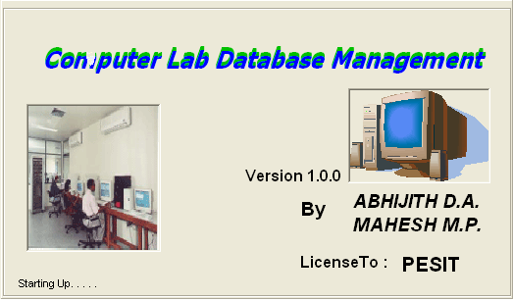
Default Administrator:
The system consists of a default administrator whose entry is made into the database automatically at the system startup if the entry is not made. Only the name and the password can be changed

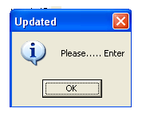

Login Form:
Login form is used to enter the login details of the user who logs into the package. This form is to be correctly filled by the students or administrator to access the related details.
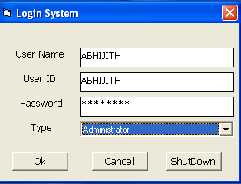

Administrator Form:
This form provides the administrator wit the facilities of adding /querying/updating the student, system, time table, lab and history information. In addition, the admin can add a new administrator to ease his work. In addition, he can change his password and logout of the session.

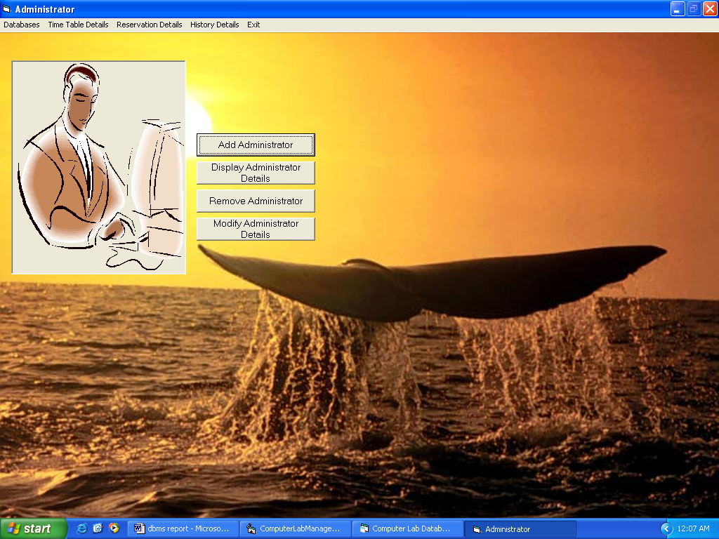

Student Form:
This form provides the student with the facilities of visiting his account, reserve the system, query the system based on the availability, processor, memory and so on. He can also view the time table and generate a report of the time table if he likes.

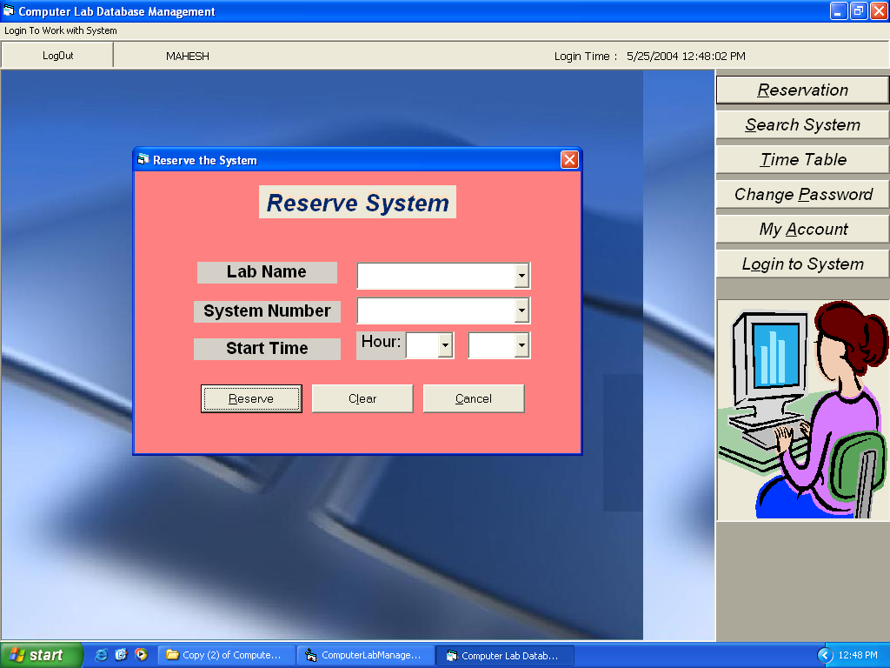

6. DATA VALIDATION

6.1 Login Validation:
A person who wishes to use the system has to complete all the details of the login screen in failure of which he will be prompted a message to fill all the details. A person who wishes to login should be either a student or an administrator of the lab.

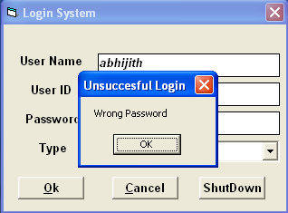

Administrator Validation:
An administrator can be added to the existing labs only by another administrator.
Reservation Validation:
Reservation can be done only by a student after he logs in. A student cannot make reservation to his friends. Reservation can be made for the current day only.
The reservation so made will be automatically deleted by the system after that day.
Student Validation:
A student has a unique id which is the register number. If a student with the same id is entered, an error message is displayed.
A student can be added only to the existing labs by the administrator. The student semester text box will take only values from 1-8.
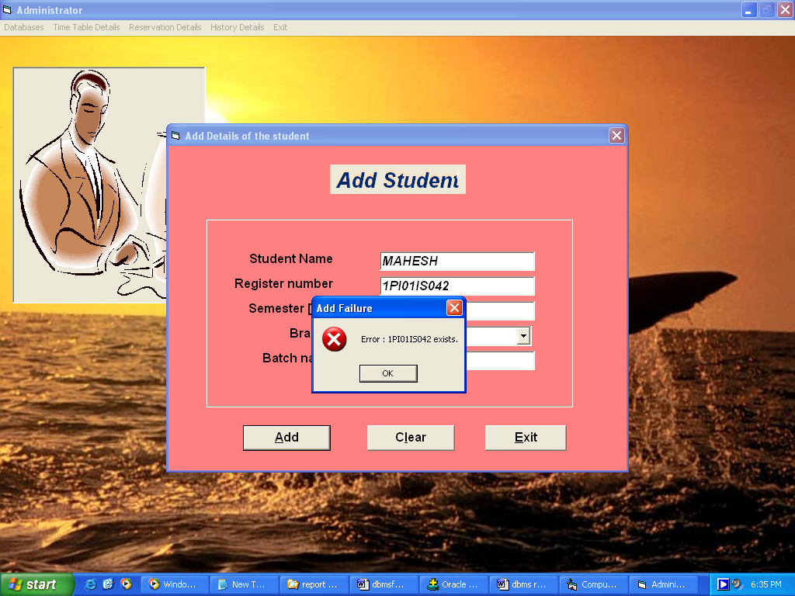

Time-Table Validation:
Time Table can be added by an administrator to the existing labs only. He has to choose between the day of the week and the lab name from a combo- box which is filled by querying the database automatically on the form load.

System Validation:
A system can be added to the existing labs only. The system count in the lab table will be updated on each entry of the system into the database.

  - Relation Validation

- LAB:
In lab table, lab_name is made the primary key to identify department and number of system.
- STUDENT
In student table, register number is made the primary key and name should not be null. Register number determines all his details.
- PASSWORD
A reference is made to student table through student id which is the register number of student.
- SYSTEM
In system, system no is given which determines its attributes in a particular lab. The reference key is lab which is in lab table.
- RESERVATION
System number and reservation time is the primary key here. User id references the student’s register number and system number references the system.

7. REPORTS
Report generation is an important phase in any system. The main idea behind report generation is to obtain a detailed status of the system at a particular instance of time. In addition, a reason behind this is the lack of confidence on the software or hardware maintaining the data.
The reports that are being generated in our project are as follows:
- Student Details Report
- Administrator Details Report
- System Report
- History Report

Student details report:
  - All students:
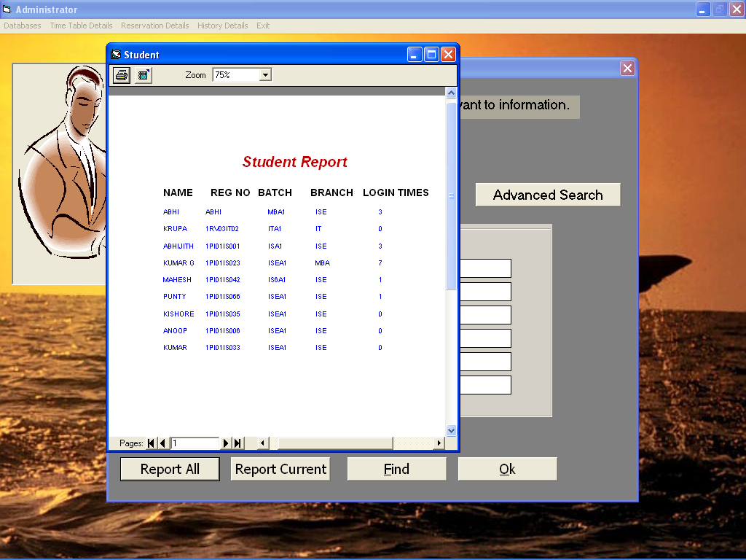

This report displays the details of all the students present in the database.

2. Customized student report
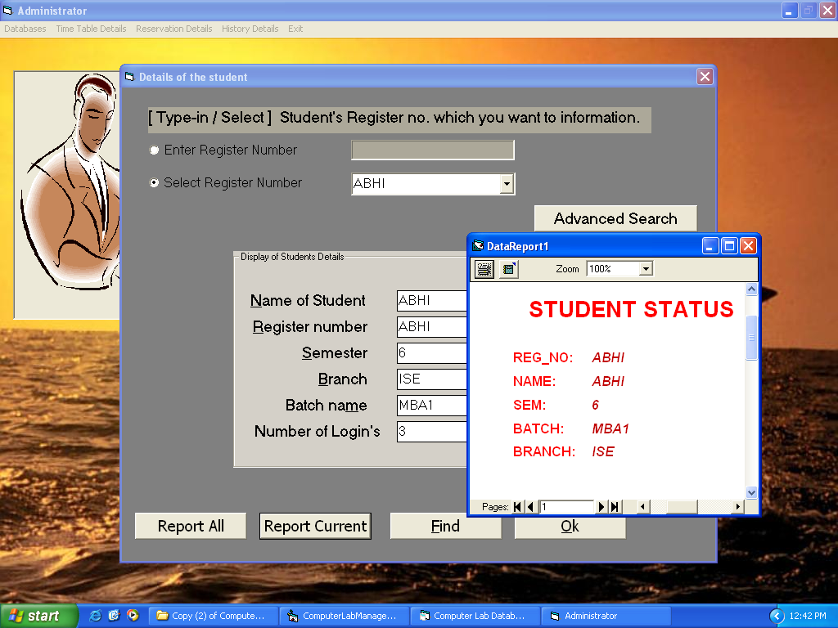

This report displays the details of the selected student. These include the id, name, sem and so on.

3. Administrator Report:
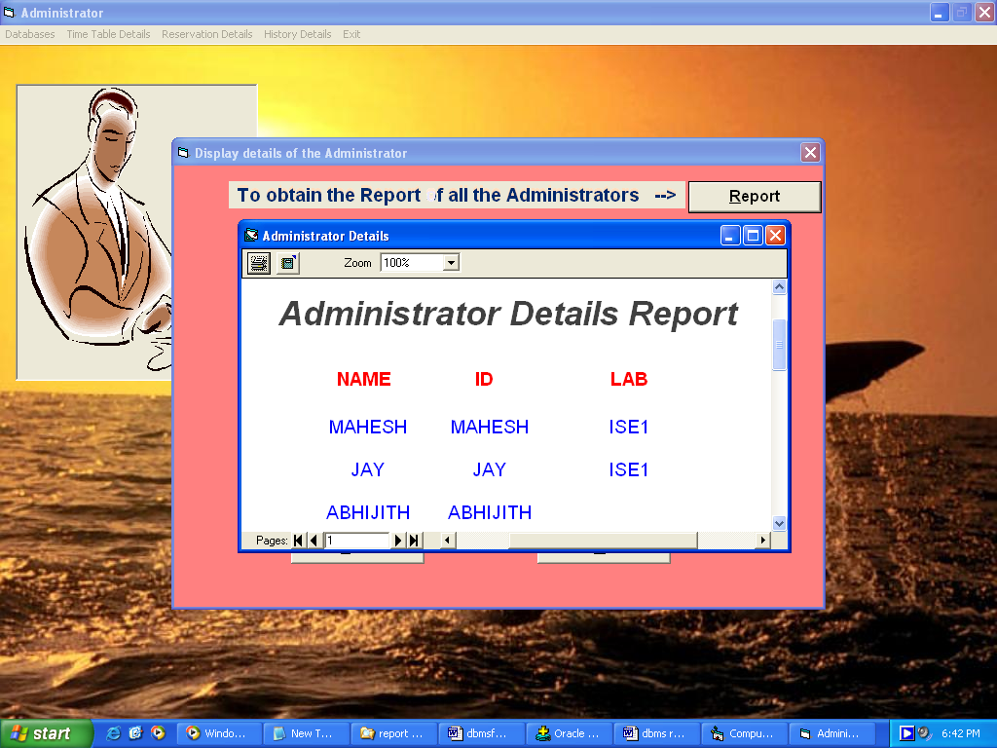

This report displays the administrator details.

4. System Report:
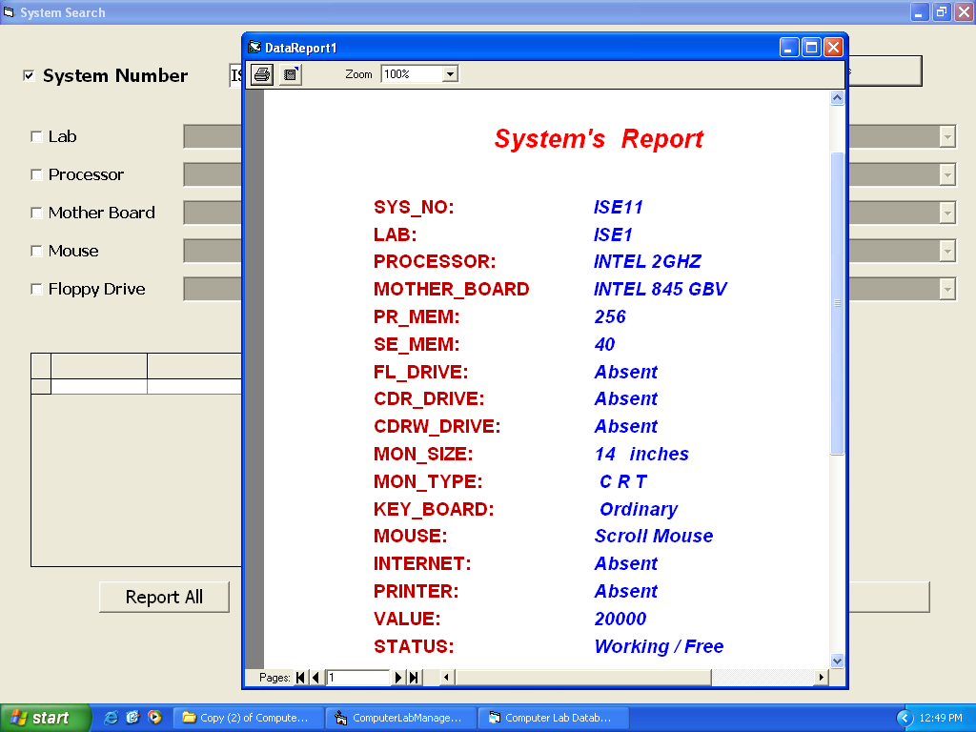

This form displays the report of the selected system.

5. History Report:
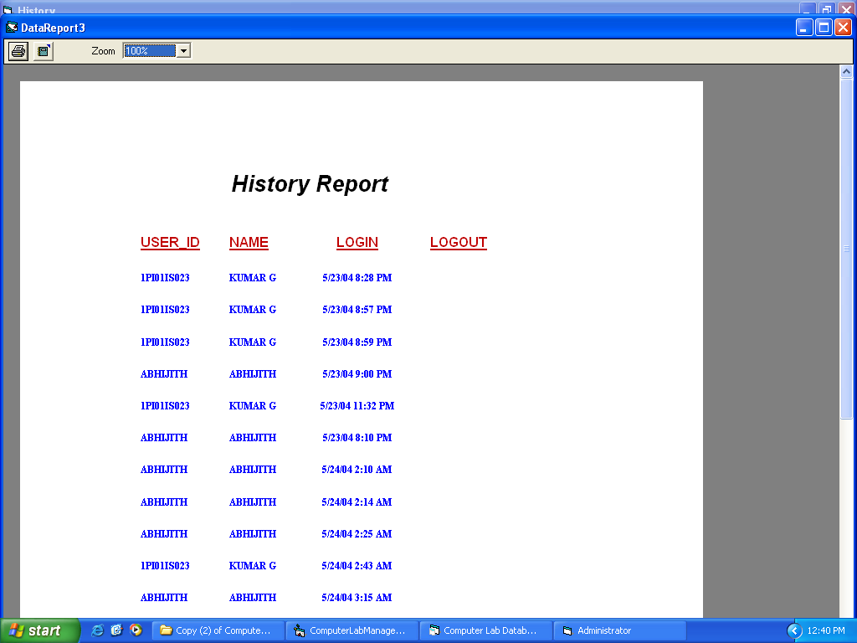

From this report, we get to know the users who have used the system.

8. USER MANUAL
User manuals are provided to guide the user in working in close interaction with the system. The users who find something difficult to understand the system may use these manuals to proceed their further transactions with the system without hiccups. The following user manuals help the student as well as the administrator to go through the details of the database.
The user manuals are as shown below:
- Administrators
Search Student
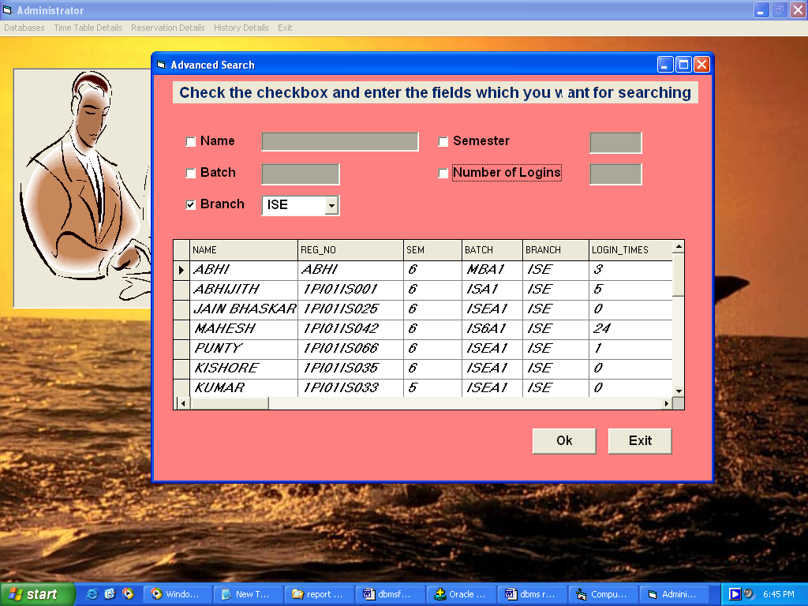

History Details
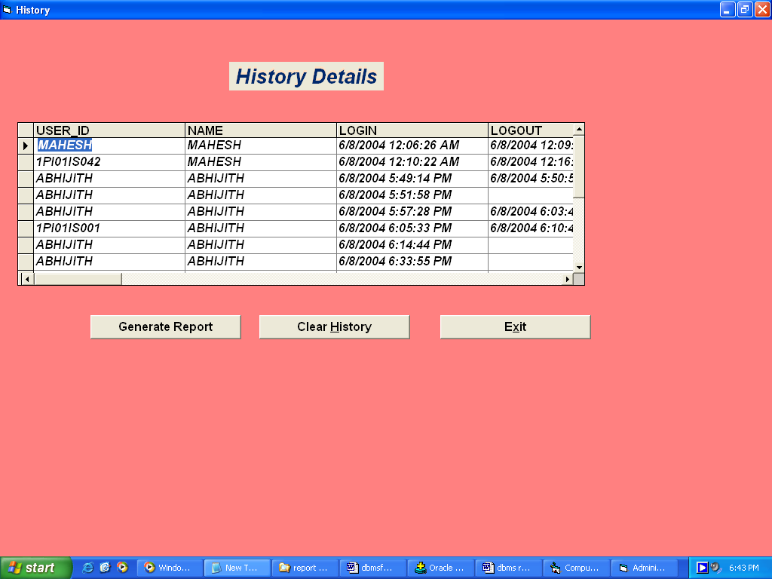

- Student
Search System
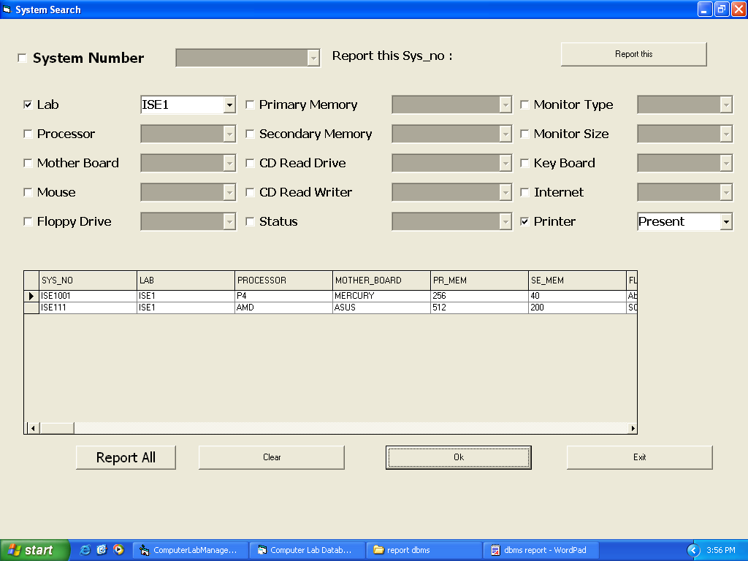

Display Time Table

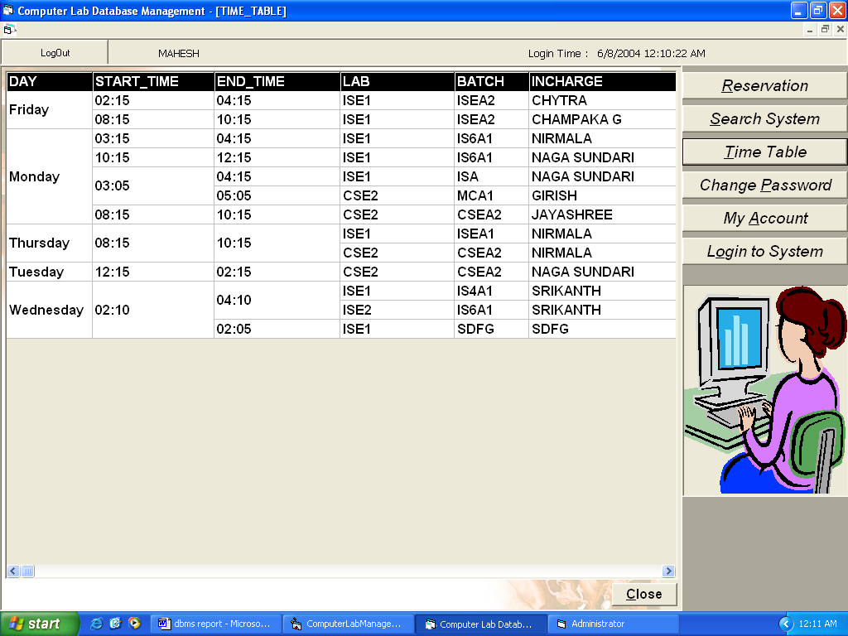

9. FUTURE ENHANCEMENTS

The “computer lab database management” can be enhanced in future by providing the following features:
- A centralized server based system which caters to all the type of users of the system.
- Performing real time operations and providing concurrency control feature to handle multiple requests by the users.
- Barcode feature which allows the user having a card generated by the system.
- An account oriented feature which takes care of the lab hours filled in by the user (student/administrator).

10. CONCLUSION

The main aim of the project is to provide a database for a computer lab/a call centre and provide features for Online Transaction which has been successfully performed.
The package is a very user friendly one which helps the administrator to manage the lab efficiently with the use of minimum number of buttons. The lab administrator can be at complete ease with the database .The package has been normalized till the 3rd Normal form and hence does not have to deal with the data redundancy. This makes the project a robust and efficient one which reduces manual and enormous amount of paperwork involved.
The package for student is so as to provide those secured features for transacting with the Computer lab. He can generate the report of his details/account, reserve the system and extend himself to query the system depending upon his needs.
Indeed the computer lab management database eases the work of all those persons who use the computer lab in a particular institution or any sort of a computer lab oriented environment.
T

11. BIBLIOGRAPHY
- Fundamentals of Database Systems
Third Edition, By
Ramez Elmasri
Shamkant B. Navathe
- Visual Basic 6: The Complete Reference
By, Noel Jerke
- SAMS Teach Yourself Visual Basic 6.0 in 21 days
- SAMS Teach Yourself PL/SQL in 21 days

Website:
www.pes.edu
www.oracle.com
www.samspublishing.com

